f

# Travel

You need to add 25 things to this document. (Make sure to number them just as I did in the example.) It may be helpful to copy and paste this list and then fill it in as you go along. All image names must start with your location, e.g yellowstone_sunset.jpg unless you are using a link from the internet.

[Link to Travel Files](https://drive.google.com/drive/folders/1q5vIvE3hqb4EL_0czgf-xbAWGyGAP2fc)

## Location

1. Primary Image of Location as a gif



1. Primary Image of Location as non-gif.

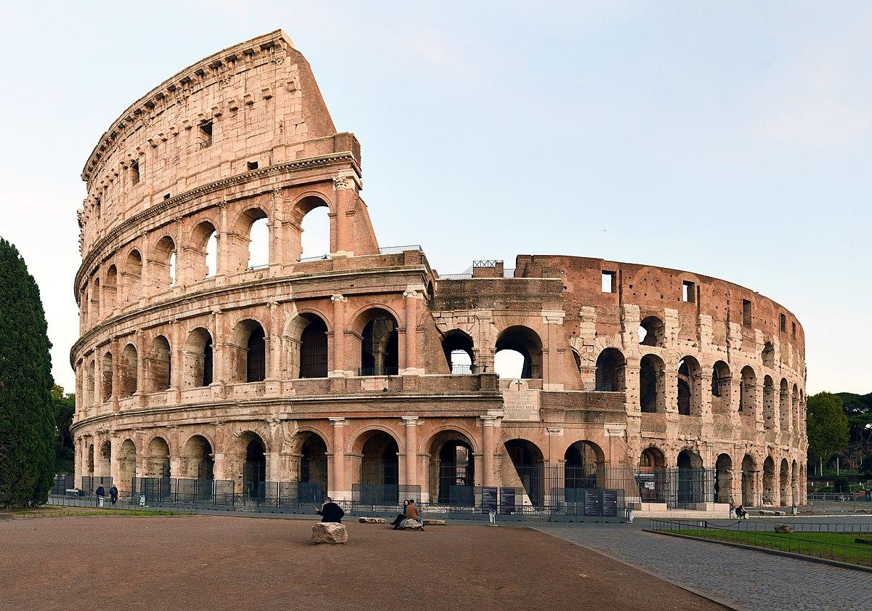

1. Name of file with gif file (make sure to add the picture to the proper Google Drive!)

colosseum-rome.gif

1. Name of file with non gif file (make sure to add the picture to the proper Google Drive!)

colosseum-rome.jpg

1. **Geographical Location**: Asia, Africa, North America, South America, Antarctica, Europe, Australia

Europe

1. Paragraph One about the location

Rome is one of the oldest metropolitan areas in the world. With a history dating back to 700 BC with the birth of the Roman Empire, the city has maintained its status as a cultural and historical hub of Europe. The city is peppered with ancient monuments, statues, and piazzas from different eras of history. The most famous location, the Colosseum, is touted as one of the seven modern wonders of the world. Rome houses several world famous museums, such as the Borghese and the Vatican Museum. It is also the only city in the world to encompass a recognized country, Vatican City.

1. Paragraph Two about the location.

Rome is also a great location for food, wine, and leisure. At the heart of Italy, Rome is a central gathering place for a diverse array of Italian cuisine; Neapolitan Pizza from the south, Tuscan wine, and truffle from the north. Rome’s most famous dish is carbonara. Beyond the food, Rome has a vibrant nightlife. The Trastevere neighborhood has plenty of bars and clubs for patrons and, just over the river, Centro’s shopping district is always bustling.

1. **Photo Gallery – (Just write Photo Gallery)**

## Rome

1. Primary Image of Location as a gif



A view of the colosseum ruins at night.

1. Primary Image of Location as non-gif.



A view of the colosseum during the day.

1. Name of file with gif file (make sure to add the picture to the proper Google Drive!)

colosseum-rome.gif

1. Name of file with non gif file (make sure to add the picture to the proper Google Drive!)

colosseum-rome.jpg

1. **Geographical Location**: Asia, Africa, North America, South America, Antarctica, Europe, Australia

Europe

1. Paragraph One about the location

Rome is one of the oldest metropolitan areas in the world. With a history dating back to 700 BC with the birth of the Roman Empire, the city has maintained its status as a cultural and historical hub of Europe. The city is peppered with ancient monuments, statues, and piazzas from different eras of history. The most famous location, the Colosseum, is touted as one of the seven modern wonders of the world. Rome houses several world famous museums, such as the Borghese and the Vatican Museum. It is also the only city in the world to encompass a recognized country, Vatican City.

1. Paragraph Two about the location.

Rome is also a great location for food, wine, and leisure. At the heart of Italy, Rome is a central gathering place for a diverse array of Italian cuisine; Neapolitan Pizza from the south, Tuscan wine, and truffle from the north. Rome’s most famous dish is carbonara. Beyond the food, Rome has a vibrant nightlife. The Trastevere neighborhood has plenty of bars and clubs for patrons and, just over the river, Centro’s shopping district is always bustling.

1. **Photo Gallery – (Just write Photo Gallery)**
   1. trevi-fountain-rome.jpg
      1. A decorated marble fountain with several roman statues dancing.
   2. vatican-rome.jpg
      1. An aerial view of a circular forum outlined with ornate columns
   3. spanish-steps-rome.jpg
      1. Decorative steps sitting behind a fountain with a small church at the top.
   4. roman-forum-rome.jpg
      1. A ruin of large columns supporting a roof surrounded by smaller ruins.
   5. Victor-emmanuel-rome.jpg
      1. An ornate marble building with bronze statues of angels and chariots, and the Italian flag on either side.
2. Names
   1. Frank Pelosi